21BDS0340

Abhinav Dinesh Srivatsa

BCSE101E, VL2021220107100 – TC2 (Theory)

BCSE101E, VL2021220107101 – L15+L16+L29+L30 (Lab)

# M12_CSQ1: Write a problem analysis chart (PAC), Algorithm and flowchart to calculate the age of a housefly in seconds, given the number of days the housefly lived.

## PAC:

|  |  |  |  |
| --- | --- | --- | --- |
| **Data** | **Processing** | **Output** | **Alternative Solutions** |
| NoDays = user input | NoSeconds = NoDays * 24 * 3600 | NoSeconds | Define NoDays |

## Table Description automatically generated with low confidenceFlowchart:

## Algorithm:

Read NoDays

Calculate NoSeconds = NoDays * 24 * 3600

Display NoSeconds

## Code:

days = int(input("Enter days the fly has been alive: "))

seconds = days * 24 * 3600

print(f"The fly has lived for {seconds} seconds")

# M12_CSQ2: Milk is collected for sales from nearest ‘n’ farms to the milk booth. Given the amount of milk from ‘n’ farms in litres and ml. Write a PAC chart, algorithm, and flowchart to compute total quantity of milk in the booth.

## PAC:

|  |  |  |  |
| --- | --- | --- | --- |
| **Data** | **Processing** | **Output** | **Alternative Solutions** |
| NoFarms = user input  L1, L2, L3, … = user input  M1, M2, M3, … = user input | TotalM = M1 + M2 + …  TotalL = L1 + L2 + L3 + …  TotalL = TotalL + TotalM / 1000  TotalM = TotalM % 1000 | TotalL  TotalM | Define NoFarms  Define NoLiters, NoMillis |

## Diagram, schematic Description automatically generatedFlowchart:

## Algorithm:

Read NoFarms

Read L1, L2, L3, …

Read M1, M2, M3, …

Calculate TotalM = M1 + M2 + …

Calculate TotalL = L1 + L2 + L3 + …

Calculate TotalL = TotalL + TotalM / 1000

Calculate TotalM = TotalM % 1000

Display TotalL

Display TotalM

## Code:

farms = int(input("Enter number of farms: "))

litre_sum = 0

milli_sum = 0

for i in range(farms):

    milk = input(f"Farm {i + 1}: ").split(" ")

    litre_sum += int(milk[0])

    milli_sum += int(milk[1])

# carrying over the extra milliliters to liters

litre_sum += int(milli_sum / 1000)

milli_sum %= 1000

print(f"Total is {litre_sum} liters and {milli_sum} milliliters")

# M12_CSQ3: Write a PAC chart, algorithm, and flowchart for converting the given two-digit number into its corresponding Roman numeral.

## PAC:

|  |  |  |  |
| --- | --- | --- | --- |
| **Data** | **Processing** | **Output** | **Alternative Solutions** |
| Number = user input | Tens = Number // 10  Units = Number % 10  Roman = ‘’  If Tens is between 0 and 4, then concatenate Tens amount of ‘X’  Else if Tens is 4, concatenate ‘XL’  Else if Tens is between 4 and 9, then concatenate ‘L’ + (Tens – 5) amount of ‘X’  Else if Tens is 9, then concatenate ‘XC’  Else if Tens is 10, then concatenate ‘C’  If Units is between 0 and 4, then concatenate Units amount of ‘I’  Else if Units is 4, concatenate ‘IV’  Else if Units is between 4 and 9, then concatenate ‘V’ + (Tens – 5) amount of ‘I’  Else if Units is 9, then concatenate ‘IX’ | Roman | Define Number |

## Flowchart:

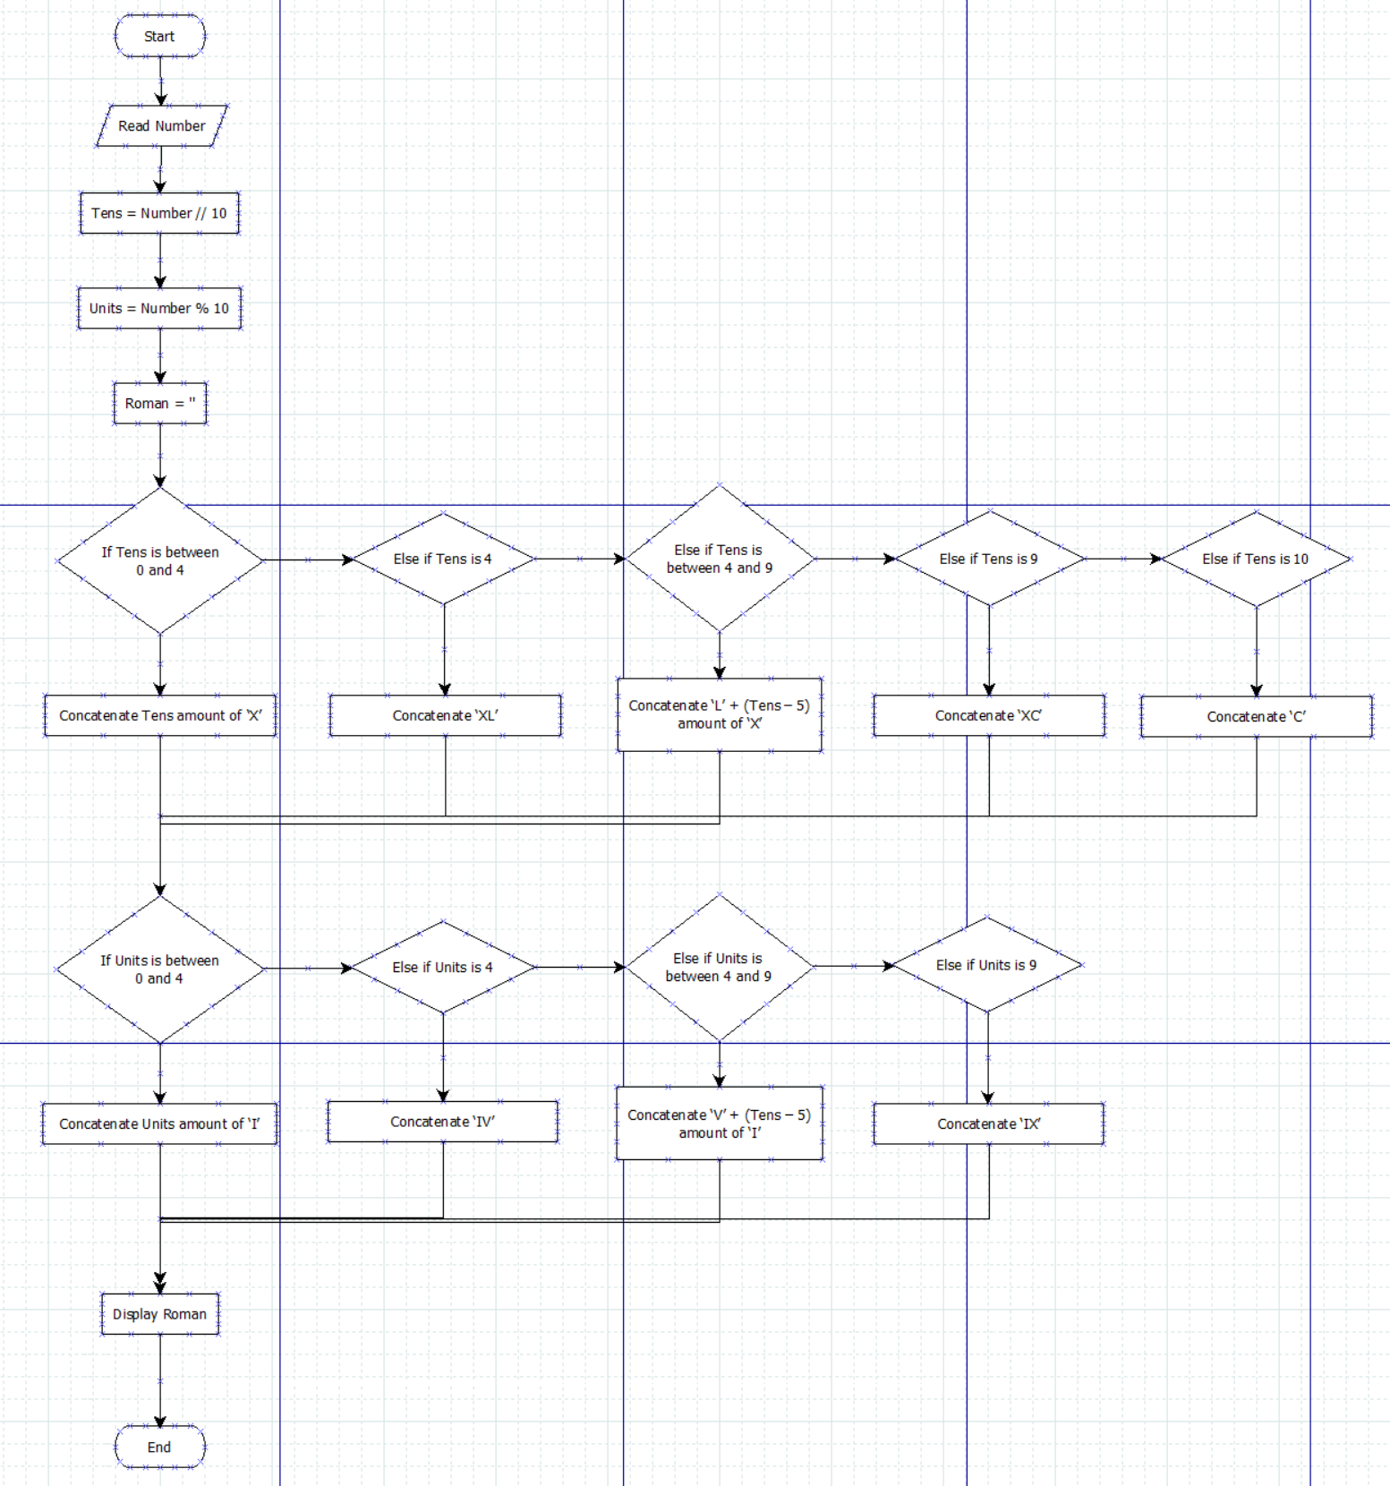

## Algorithm:

Read Number

Tens = Number // 10

Units = Number % 10

If Tens is between 0 and 4, then concatenate Tens amount of ‘X’

Else if Tens is 4, concatenate ‘XL’

Else if Tens is between 4 and 9, then concatenate ‘L’ + (Tens – 5) amount of ‘X’

Else if Tens is 9, then concatenate ‘XC’

Else if Tens is 10, then concatenate ‘C’

If Units is between 0 and 4, then concatenate Units amount of ‘I’

Else if Units is 4, concatenate ‘IV’

Else if Units is between 4 and 9, then concatenate ‘V’ + (Tens – 5) amount of ‘I’

Else if Units is 9, then concatenate ‘IX’

Display Roman

## Code:

number = int(input("Enter number: "))

roman = ""

tens = number // 10

units = number % 10

if tens > 0 and tens < 4:

    roman += (tens * 'X')

elif number / 10 == 4:

    roman += 'XL'

elif tens > 4 and tens < 9:

    roman += 'L' + ((tens - 5) * 'X')

elif tens == 9:

    roman += 'XC'

elif tens == 10:

    roman += 'C'

if units > 0 and units < 4:

    roman += (units * 'I')

elif units == 4:

    roman += 'IV'

elif units > 4 and units < 9:

    roman += 'V' + ((units - 5) * 'I')

elif units == 9:

    roman += 'IX'

print(f"{number} in Roman numerals is {roman}")

# M12_CSQ4: Write a PAC chart, Algorithm and Flowchart for adding two complex numbers,  input two complex numbers and add the same to produce the result. After producing the result, print the real part and imaginary part separately.

## PAC:

|  |  |  |  |
| --- | --- | --- | --- |
| **Data** | **Processing** | **Output** | **Alternative Solutions** |
| Vector1 = user input  Vector2 = user input | RealSum = Real parts of the vectors and sum  ImaginarySum = Imaginary parts of the vectors and sum | 'Real part is ' RealSum  'Imaginary part is ' ImaginarySum | Define Vector1 and Vector2 |

## Diagram Description automatically generatedFlowchart:

## Algorithm:

Read Vector1, Vector2

Calculate RealSum = Get real parts of the vectors and sum

Calculate ImaginarySum = Get imaginary parts of the vectors and sum

Display 'Real part is ' RealSum

Display 'Imaginary part is ' ImaginarySum

## Code:

vector1 = complex(input("Enter vector 1: "))

vector2 = complex(input("Enter vector 2: "))

real_sum = vector1.real + vector2.real

imaginary_sum = vector1.imag + vector2.imag

print(f"Real part is: {int(real_sum)}")

print(f"Imaginary part is: {int(imaginary_sum)}")

# M12_CSQ5: Write a PAC chart, Algorithm and Flowchart to convert the given integer to the corresponding binary, octal and hexadecimal values and print the same.

## PAC:

|  |  |  |  |
| --- | --- | --- | --- |
| **Data** | **Processing** | **Output** | **Alternative Solutions** |
| Number = user input | Python in built functions:  Bin = bin(Number)  Oct = oct(Number)  Hex = hex(number) | Bin  Oct  Hex | Define Number  Compute Bin, Oct, Hex manually |

## Flowchart:

## Algorithm:

Read Number

Calculate Bin = bin(Number)

Calculate Oct = oct(Number)

Calculate Hex = hex(number)

Display Bin, Oct, Hex

## Code:

num = int(input())

print(bin(num), oct(num), hex(num))